AYUDA DISTRIBUTION AND MONITORING APP



A Capstone Project Presented to the Faculty of the
College of Information and Communication Technology
St. John Paul II College of Davao

In Partial Fulfillment of the Requirements for the Degree
Bachelor of Science in Information Technology

By
RABE, LIEZELME B.
VILLARIN, CHRISLY H.

KAREN SHANE A. PRIETE, MIT
Adviser

May 2027
TABLE OF CONTENTS
CHAPTER |  | PAGE
1 | INTRODUCTION
 | Project Context | 4
 | Statement of the Problem | 5
 | Objectives of the Study | 6
 | Scope and Limitations | 6
2 | REVIEW OF RELATED LITERATURE AND SYSTEM
 | Digital Administrative Systems in Public Service Delivery | 7
 | Security and Access Control | 8
 | Real-Time Monitoring and Reporting | 9
 | Duplication Prevention Mechanisms | 10
 | Geographic Information Systems (GIS/GPS Mapping) | 11
 | Data Import and Interoperability Systems | 13
 | Inventory Management Systems | 14
 | DSWD Social Amelioration Program System | 15
 | DICT e-Government Services Platform | 16
 | ReliefAgad Platform Interface | 17
 | Comparison Matrix | 18
3 | TECHNICAL BACKGROUND
 | Conceptual Framework | 20
 | Software Requirements | 21
 | Hardware Requirements | 22
 | Prototype Description | 23
 | REFERENCES | 32

Chapter 1
INTRODUCTION
Ayuda refers to government assistance that provides financial or material support to individuals and families during emergencies and periods of economic hardship, enabling vulnerable sectors to meet their basic needs. As explained by Egeten, Choriyanto, and Anggrainy (2024), cash-based social assistance programs help sustain low-income households by providing immediate financial relief. Similarly, Wailissa and Muharromah (2025) emphasized that food and cash aid initiatives are essential in addressing limited access to basic resources in underserved communities.
Despite these efforts, the implementation of Ayuda programs remains challenged by issues in data management and distribution processes. According to Wailissa and Muharromah (2025), inclusion errors occur when ineligible individuals receive assistance, while exclusion errors prevent qualified beneficiaries from accessing aid. In addition, Albert, Dumagan, and Martinez (2020) highlighted that weak data systems and poor coordination contribute to delays, duplication of beneficiaries, and inefficiencies in aid delivery. These challenges affect the accuracy, transparency, and overall effectiveness of social assistance programs.
Furthermore, the lack of organized and centralized databases makes it difficult for barangay staff to efficiently manage beneficiary records, monitor distribution, and verify recipients. Without proper tracking mechanisms, duplicate claims and inconsistent reporting may occur, reducing the reliability of the distribution process. As emphasized by Gentilini, Almenfi, and Dale (2021), the use of digital systems in social protection programs improves targeting, monitoring, and accountability. Therefore, there is a need to develop a system that enables barangay staff per district to manage beneficiary records in an organized database, monitor the distribution of ayuda, prevent duplicate recipients per barangay, and generate reports for efficient tracking and verification of the distribution process.

PROJECT CONTEXT
Ayuda programs are government initiatives that provide financial or material assistance to individuals and families affected by emergencies, disasters, and economic hardship. These programs play a vital role in poverty alleviation and humanitarian response by addressing immediate needs such as food, cash aid, and basic services, particularly in vulnerable communities. However, their effectiveness depends on accurate beneficiary data, efficient coordination among implementing agencies, and reliable monitoring systems. Without these elements, delays, inconsistencies, and misallocation of resources may occur, affecting the timely and equitable delivery of assistance.
In many local government units, including those in Davao City, the implementation of Ayuda programs still relies on manual or semi-manual processes. The use of paper-based records and fragmented data systems increases the likelihood of data inaccuracies, duplication of assistance, and delays in distribution. As emphasized by Albert, Dumagan, and Martinez (2020), weak data management systems contribute to inefficiencies and targeting issues in social protection programs. These challenges make it difficult for barangay staff to manage beneficiary information, monitor aid distribution, and ensure that assistance reaches the appropriate recipients, thereby weakening transparency and overall program effectiveness.
In response to these gaps, this study proposes the development of an Ayuda Distribution and Monitoring Application designed to modernize and streamline the management of assistance programs. The system will serve as a centralized platform that enables barangay staff per district to manage beneficiary records in an organized database, monitor the distribution of ayuda, prevent duplicate recipients per barangay, and generate reports for efficient tracking and verification of the distribution process. By integrating these functions, the system aims to minimize errors, improve coordination, and ensure that assistance is delivered efficiently, transparently, and to the intended beneficiaries.

STATEMENT OF THE PROBLEM
In many communities, vulnerable populations rely heavily on the timely and accurate distribution of Ayuda for their daily survival and well-being. As discussed by Albert, Dumagan, and Martinez (2020), social protection programs in the Philippines continue to experience persistent challenges in data management and targeting accuracy. One of the main concerns is the unreliability of beneficiary information, where records are often outdated, incomplete, or inconsistently maintained. Wailissa and Muharromah (2025) explained that such data issues result in inclusion errors, where individuals who are not qualified still receive assistance, and exclusion errors, where eligible beneficiaries are left unserved.
Another significant challenge is the lack of effective monitoring and tracking mechanisms that limit efficient oversight of ayuda distribution. As noted by Hanna and Olken (2020), weak monitoring systems reduce accountability and transparency in aid delivery processes. In many cases, manual and fragmented procedures make it difficult to verify the status of assistance, leading to delays and administrative inefficiencies. In addition, poor coordination among implementing agencies contributes to duplication of assistance and slower response times, which negatively affects the overall delivery of social services. These issues highlight the difficulty faced by barangay staff in managing large volumes of beneficiary data across different districts.
Furthermore, the absence of an integrated, technology-driven system limits accurate reporting and informed decision-making in social protection programs. As emphasized by Gentilini, Almenfi, and Dale (2021), inadequate digital infrastructure weakens the responsiveness of aid distribution systems, especially during disasters and emergencies. These challenges highlight the need for an application-based ayuda distribution and monitoring system that enables barangay staff per district to manage beneficiary records in an organized database, monitor the distribution of ayuda, prevent duplicate recipients per barangay, and generate reports for efficient tracking and verification of the distribution process.

OBJECTIVES OF THE STUDY
The researchers aim to develop ayuda distribution and monitoring app in Davao City. The researchers specifically aim to:
- Enable barangay staff per district to manage beneficiary records in an organized database.
- Monitor the distribution of ayuda and prevent duplicate recipients per barangay.
- Generate reports for efficient tracking and verification of the distribution process.

SCOPE AND LIMITATIONS
This study focuses on the development of an Ayuda Distribution and Monitoring Application intended for barangay staff across different districts. The system enables barangay staff per district to manage beneficiary records in an organized database, monitor the distribution of ayuda, and prevent duplicate recipients per barangay by verifying and controlling beneficiary records. It also allows authorized users to generate reports for efficient tracking and verification of the distribution process. The study covers the design, development, and testing of the system within a controlled environment to ensure its functionality, usability, and reliability.
However, the system has certain limitations. It is primarily designed for use by barangay staff and authorized personnel, with limited access for other users. The system depends on stable internet connectivity for real-time data access and synchronization. It does not include financial management of funds or integration with national government databases. In addition, the system is limited to the management of beneficiary records and ayuda distribution within selected barangays and districts in Davao City.

Chapter 2
REVIEW OF RELATED LITERATURE
This presents previous studies, articles, and publications related to the proposed system. It helps identify existing knowledge, concepts, and findings that support the study and establish its relevance and credibility.

Digital Administrative Systems in Public Service Delivery
Digital administrative systems play a crucial role in modernizing government service delivery by centralizing data management and improving operational efficiency. Dwivedi et al. (2021) emphasized that digital platforms reduce processing delays and human errors by replacing manual workflows with automated systems. Similarly, Alsharo et al. (2021) highlighted that integrated systems enhance coordination among departments through real-time data sharing and centralized record management. These capabilities are essential in ensuring faster and more reliable public service delivery.
Laudon and Laudon (2022) explained that modern information systems support automated workflows, audit trails, and centralized databases, which strengthen transparency and accountability. Chen et al. (2022) further found that cloud-based platforms improve accessibility and reduce transaction time, particularly in time-sensitive services such as disaster response and social assistance programs. These features enable government agencies to respond more effectively to public needs. As a result, service delivery becomes more efficient and responsive.
Despite these advantages, many local government units continue to rely on fragmented or semi-manual systems. These outdated approaches lead to inefficiencies, data inconsistencies, and delays in service delivery. Poor integration limits coordination across departments and slows down decision-making processes. This highlights the need for adopting fully digital administrative systems in public service operations.

Security and Access Control
Security and access control are fundamental elements in any web-based platform, especially those responsible for handling sensitive beneficiary information. Michael E. Whitman and Herbert J. Mattord (2021) emphasized that role-based access control (RBAC) ensures only authorized individuals can access or modify data, strengthening confidentiality and integrity. By assigning specific permissions based on user roles, systems can effectively minimize unauthorized interactions and enforce accountability among users. This structured approach not only protects critical data but also ensures that system operations remain controlled and transparent.
In addition, William Stallings (2022) highlighted the importance of encryption and secure communication protocols in protecting data during transmission, particularly over public or unsecured networks. Khan et al. (2022) further noted that integrating multi-factor authentication (MFA) and real-time monitoring significantly reduces the risks of unauthorized access and insider threats. These combined security measures create multiple layers of defense, making it more difficult for attackers to breach the system. As a result, organizations can maintain stronger protection against both external and internal security risks.
Moreover, Alan Calder and Steve Watkins (2021) explained that regular security auditing and continuous monitoring improve system resilience by identifying vulnerabilities early. Sharma et al. (2023) added that layered security architecture, which combines authentication, authorization, and encryption, significantly lowers the likelihood of data breaches. These strategies collectively enhance compliance with data privacy regulations and strengthen public trust in digital government systems. However, many local platforms still fail to fully implement measures like MFA and routine audits, leaving sensitive data exposed to potential threats.

Real-Time Monitoring and Reporting
Real-time monitoring and reporting systems play a vital role in improving administrative decision-making by providing timely and accurate information on system activities. Michael Q. Patton (2020) explained that dashboard-based platforms enable administrators to visualize data patterns and quickly detect inefficiencies or delays in service delivery. In the same way, Donna Mertens (2021) emphasized that real-time tracking enhances resource allocation by supporting data-driven decisions. These capabilities allow organizations to respond more effectively to operational challenges and ensure smoother service implementation.
Furthermore, Michael Chui et al. (2021) found that organizations utilizing real-time analytics in public service systems achieved faster response times and improved overall efficiency. In government assistance programs, this enables more precise monitoring of aid distribution and beneficiary status as events occur. Thomas H. Davenport and Rajeev Ronanki (2021) also highlighted that automated reporting systems help minimize human errors while promoting transparency through consistent and reliable report generation. In the Philippine setting, Habitan et al. (2023) observed that digital monitoring tools improved coordination among local agencies and reduced delays during disaster response operations.
In addition, real-time monitoring systems support the early identification of inconsistencies in aid distribution, allowing administrators to promptly resolve issues such as delays or missing data. Kumar et al. (2022) noted that real-time analytics enhances operational responsiveness by enabling continuous system feedback and necessary adjustments. This makes public service delivery more adaptive, efficient, and reliable over time. However, many local government units still rely on manual reporting processes, which limit transparency, slow down decision-making, and increase the likelihood of inaccurate data. This situation highlights the urgent need to adopt integrated real-time monitoring tools in Ayuda distribution systems.

Duplication Prevention Mechanisms
Duplication prevention plays a vital role in maintaining fairness and efficiency within social assistance programs by ensuring that resources are properly allocated to eligible beneficiaries. The World Bank (2021) emphasized that errors in beneficiary targeting, particularly duplicate records, can weaken program effectiveness by diverting limited support away from those who truly need it. When multiple entries exist for a single individual, it creates imbalance and reduces the overall impact of aid distribution efforts. Therefore, eliminating duplication is essential to achieving equitable and accurate delivery of assistance.
The Organisation for Economic Co-operation and Development (2021) highlighted that modern beneficiary management systems rely on unique identifiers and database matching techniques to effectively minimize duplication errors. These methods ensure that each beneficiary receives assistance only once within a given program cycle, thereby promoting transparency and accountability. Similarly, the United Nations Development Programme (2022) reported that digital verification systems greatly enhance the accuracy of beneficiary data in both welfare and humanitarian programs. In addition, Gupta and Verma (2021) explained that using multiple identifiers such as names, birthdates, and addresses improves data matching processes, particularly in large-scale databases where inconsistencies are more likely to occur.
Moreover, automated validation mechanisms such as duplicate alerts and record filtering significantly improve the efficiency of verifying beneficiary information. Park et al. (2023) found that automated duplication detection systems not only increase accuracy but also reduce administrative workload by quickly identifying repeated entries in large datasets. These tools allow administrators to respond immediately to discrepancies, ensuring that records remain accurate and reliable over time. However, many local government systems still rely on manual verification processes, which are more prone to human error and duplication issues.

Integration for Local Government Needs
The integration of web-based systems within local government units plays a significant role in improving coordination, efficiency, and transparency in delivering public services. O’Leary (2021) emphasized that cloud-based government platforms allow seamless data integration across various agencies, enhancing interoperability and information sharing. Through these systems, departments can access and exchange information more efficiently, reducing delays and improving service outcomes. As a result, government operations become more streamlined and responsive to the needs of the public.
Janssen et al. (2021) highlighted that interoperability is essential in eliminating data silos among government offices, enabling more coordinated and efficient service delivery. In the same way, Zuiderwijk et al. (2022) explained that digital government platforms enhance transparency by promoting open data access and incorporating citizen feedback mechanisms. In the Philippine setting, Luna et al. (2021) found that digital coordination tools improved disaster response efficiency and minimized delays in aid distribution. These technologies enable local government units to respond more effectively by providing real-time access to essential data and information.
Moreover, integrated systems contribute to better decision-making by consolidating information from multiple departments into a single platform, reducing duplication of efforts, and improving data accuracy. Gil-Garcia et al. (2022) noted that interoperable e-government systems enhance operational efficiency by enabling faster data exchange and more coordinated service delivery across agencies. This leads to more timely, consistent, and data-driven government responses that benefit the community. However, many local government units still face challenges such as limited internet connectivity, lack of full system integration, and continued reliance on manual processes. These issues highlight the importance of developing a fully integrated, web-based Ayuda distribution and monitoring system tailored for local government use.

Geographic Information Systems (GIS / GPS Mapping)
Geographic Information Systems contribute significantly to spatial analysis in government operations. Spatial data visualization is a primary capability, as Longley et al. (2021) stated that GIS enables clear mapping and interpretation of location-based information. Improved planning and allocation is supported through geographic insights that guide decision-makers in distributing resources effectively. Location-based decision support enhances the ability of agencies to respond to community needs with precision. These functions strengthen overall service delivery through informed geographic analysis.
In addition, GIS enhances monitoring and transparency in public programs. Accurate beneficiary mapping is emphasized by Goodchild and Li (2020), who explained that GIS allows precise identification of service recipients based on location. Coverage analysis helps determine which areas receive assistance and which remain underserved. GPS tracking capabilities further improve monitoring at district and barangay levels by providing real-time location data. Targeted service delivery becomes more achievable as geographic patterns are clearly identified and addressed. This also supports faster validation of field reports and reduces inconsistencies in geographic records, ensuring more reliable administrative outputs.
At the same time, several considerations influence the effectiveness of GIS implementation. Technical complexity may require specialized skills and training for proper system use. Data accuracy and updating are essential to maintain reliable geographic information. Infrastructure requirements, such as stable connectivity and mapping tools, can affect system performance. Integration with other platforms is also necessary to maximize GIS functionality in government services. Additionally, continuous system maintenance and capacity-building programs are needed to ensure long-term usability and efficiency of GIS-based solutions. These aspects highlight the importance of proper planning and support in GIS adoption.

Data Import and Interoperability Systems
Data import and interoperability systems are fundamental in enhancing efficiency within government operations. System interoperability is explained by Ojo et al. (2021), who noted that it enables different platforms to communicate and exchange data effectively. Reduction of data duplication occurs when systems share consistent and synchronized information. Improved coordination across departments is achieved through seamless data flow. These capabilities strengthen overall administrative performance. This also allows faster consolidation of records from multiple sources, reducing delays in processing government services. In addition, it supports real-time updates, ensuring that all stakeholders work with the most current and accurate information.
Furthermore, integrated data processes support more efficient service delivery. Seamless information exchange is emphasized by Janssen and Estevez (2020), highlighting its role in connecting fragmented systems. Centralized data synchronization ensures that all departments access updated and consistent information. Streamlined beneficiary management is achieved through automated data import features. Minimization of manual encoding errors further improves data accuracy and reliability. This also enhances operational transparency, as data movements can be tracked and validated across different systems. Moreover, it improves decision-making by providing a unified and comprehensive view of organizational data.
At the same time, certain challenges affect the effectiveness of interoperability systems. Compatibility issues between platforms may limit smooth data exchange. Data standardization requirements are necessary to ensure consistency across systems. Security considerations during data transfer must be addressed to protect sensitive information. Ongoing system maintenance and updates are also required to sustain performance. Additionally, proper governance frameworks are needed to regulate data sharing and ensure compliance with institutional policies. These aspects underscore the need for well-designed and secure interoperability frameworks.

Inventory Management Systems
Inventory management systems serve a vital function in organizing and controlling resources within public service operations. Real-time tracking of supplies is a key feature, as Nguyen et al. (2020) explained that digital platforms provide continuous visibility of stock levels and distribution history. Transparency in resource movement is strengthened since every transaction is recorded and monitored systematically. Improved operational efficiency is achieved through accurate data, allowing administrators to make timely decisions. These elements contribute to a more structured and reliable inventory process. This helps prevent resource misallocation by ensuring that supply data is always updated and accessible to authorized personnel.
Furthermore, automation enhances the effectiveness of inventory systems in managing government resources. Reduction of shortages and overstocking is highlighted by Kumar and Singh (2021), who noted that automated tracking ensures balanced allocation of supplies. Efficient distribution management supports programs involving food packs and financial assistance, ensuring resources reach the intended recipients. Accurate record-keeping also minimizes discrepancies and supports accountability in operations. In addition, streamlined workflow processes reduce manual intervention and administrative burden. This allows personnel to focus more on planning and decision-making rather than repetitive encoding tasks.
On the other hand, certain operational concerns still affect the performance of inventory systems in some institutions. System integration challenges may arise when inventory platforms are not fully connected with other administrative systems. Data synchronization issues can impact the accuracy of stock information across different departments. Limited technical infrastructure may also restrict the full utilization of automated features in some local government units. Need for continuous system monitoring remains essential to maintain data accuracy and system functionality.
REVIEW OF RELATED SYSTEM
This section reviews existing systems related to the proposed Ayuda Distribution and Monitoring App, highlighting their strengths and limitations. The discussion establishes the need for the proposed system to improve efficiency, transparency, and monitoring of Ayuda distribution in Davao City.

DSWD Social Amelioration Program System


Figure 1. DSWD Social Amelioration Program System

(Source: https://dswdprogram.com/social-amelioration-program/)
The Social Amelioration Program (SAP) by the Department of Social Welfare and Development provided emergency cash assistance to qualified beneficiaries during crises such as the COVID-19 pandemic (DSWD, 2023). While it enabled large-scale aid distribution, SAP faced challenges including delayed validation, duplicate records, limited real-time monitoring, and reliance on manual processes, which sometimes slowed delivery and reduced transparency.
The proposed Ayuda Distribution and Monitoring Application improves on SAP by introducing a centralized beneficiary database, real-time monitoring, and district-based management for barangay staff. Unlike SAP, it supports structured beneficiary categorization and duplicate prevention mechanisms, ensuring more accurate and efficient aid distribution. It also enhances reporting capabilities for better decision-making and transparency at the local government level.

DICT e-Government Services Platform
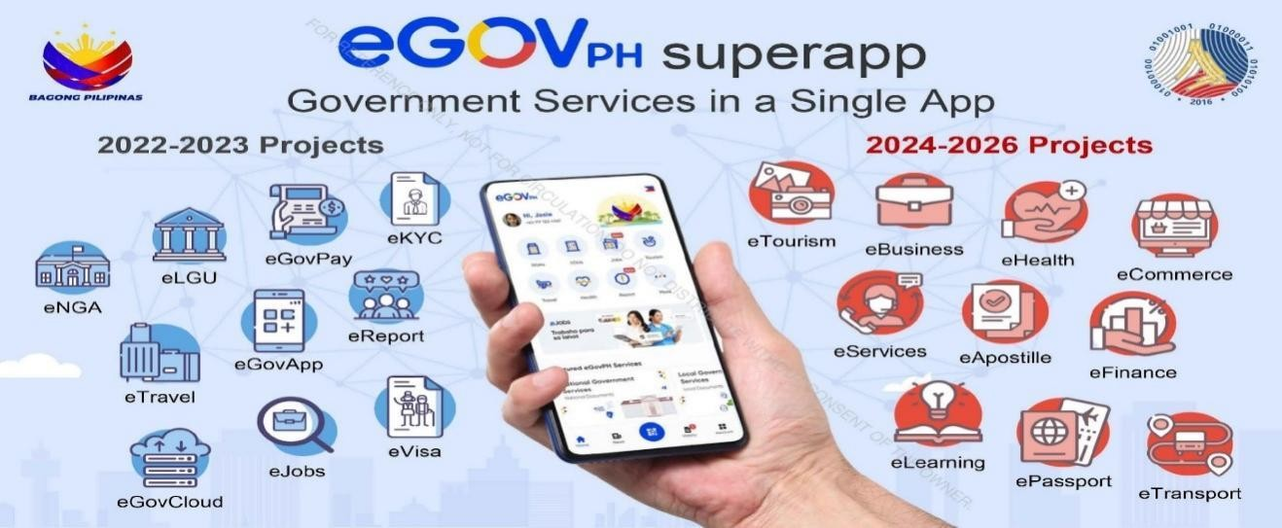

Figure 2. DICT e-Government Services Platform

(Source: https://coe-psp.dap.edu.ph/compendium-innovation/the-philippinegovernments-digital-transformation-through-dicts-e-government-initiatives/)
The Department of Information and Communications Technology (DICT) promotes e-Government systems to modernize public service delivery in the Philippines, encouraging agencies and LGUs to adopt digital platforms for improved efficiency, accessibility, and transparency. However, many LGUs still rely on semi-manual systems such as spreadsheets and paper-based records, which limit real-time monitoring and increase data inconsistencies.
The proposed Ayuda Distribution and Monitoring Application addresses these limitations by enabling centralized beneficiary management, real-time monitoring, and district-based coordination for barangay staff. It also supports mobile access and organized data processing, improving efficiency and transparency in social assistance programs. It further reduces administrative workload by automating key processes such as data encoding and validation. This ensures faster and more reliable service delivery in local government operations.
ReliefAgad platform interface
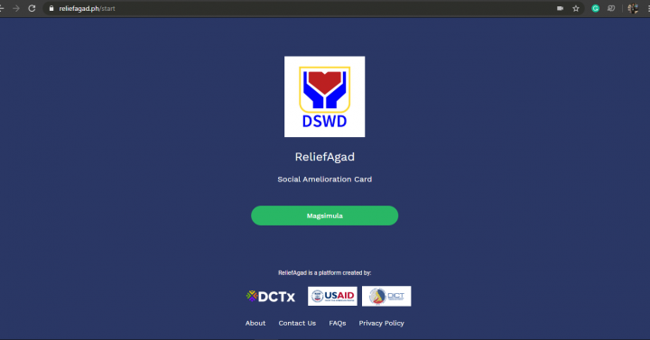
Figure 3. ReliefAgad platform interface

(Source: www.pna.gov.ph)
The ReliefAgad platform was developed to support the Social Amelioration Program (SAP) by enabling online registration, digital beneficiary data collection, and faster aid distribution. It reduced manual encoding and allowed beneficiaries to apply remotely, improving accessibility during emergencies. However, it still faced limitations in real-time monitoring, LGU-level coordination, and centralized reporting systems.
The proposed Ayuda Distribution and Monitoring Application enhances ReliefAgad by adding GPS-based location tracking, barangay-level district management, inventory tracking of aid resources, and automated duplicate detection. It also strengthens reporting and monitoring functions, making it more suitable for local government operations. These improvements allow administrators to have better control over beneficiary validation and aid distribution processes. This results in more accurate and efficient delivery of assistance at the local level.

COMPARISON MATRIX
The table below elaborates on the key features of the proposed system, among others. The checked (✓) marks emphasize its features, and the (✗) indicates its absence.
Table 1. Related System Comparison Matrix
Features |  | DSWD  SAP | ReliefAgad  Platform | DICT eGov  Services | Ayuda  Distribution and  Monitoring  App
Centralized Beneficiary  Database |  | ✗ | ✗ | ✗ | ✓
Real-Time Application  Tracking |  | ✗ | ✗ | ✗ | ✓
Automated Duplicate  Detection |  | ✗ | ✗ | ✗ | ✓
Beneficiary Registration  System |  | ✗ | ✓ | ✗ | ✓
GPS/Location-Based  Mapping |  | ✗ | ✗ | ✗ | ✓
Inventory Tracking  System |  | ✗ | ✗ | ✗ | ✓
LGU/Barangay District-  Level Management |  | ✗ | ✗ | ✗ | ✓
Integrated Monitoring  Dashboard |  | ✗ | ✗ | ✓ | ✓
Report Generation |  | ✗ | ✗ | ✗ | ✓
File Import/Export |  | ✗ | ✗ | ✗ | ✓

The comparison shows that DSWD SAP, ReliefAgad Platform, and DICT eGov Services have limited coverage across most of the identified features. All three systems do not support centralized beneficiary databases, real-time application tracking, automated duplicate detection, GPS/location-based mapping, inventory tracking systems, LGU/barangay district-level management, report generation, and file import/export. ReliefAgad Platform provides support for a beneficiary registration system, while DICT eGov Services includes an integrated monitoring dashboard. However, these features are isolated and not collectively available within a single system.
In contrast, the Ayuda Distribution and Monitoring App supports all the features listed in the table. It includes centralized beneficiary data management, real-time tracking, automated duplicate detection, and a beneficiary registration system. In addition, it incorporates GPS/location-based mapping, inventory tracking, and LGU/barangay district-level management, along with an integrated monitoring dashboard, report generation, and file import/export capabilities. This complete set of functionalities highlights its advantage as a more comprehensive and unified solution for aid distribution and monitoring.
Overall, the comparison emphasizes the gaps in existing systems and the need for an integrated platform that consolidates essential functionalities into a single application. By addressing the limitations observed in DSWD SAP, ReliefAgad Platform, and DICT eGov Services, the proposed system improves efficiency, transparency, and coordination in the distribution process, particularly at the local government level.

Chapter 3
TECHNICAL BACKGROUND
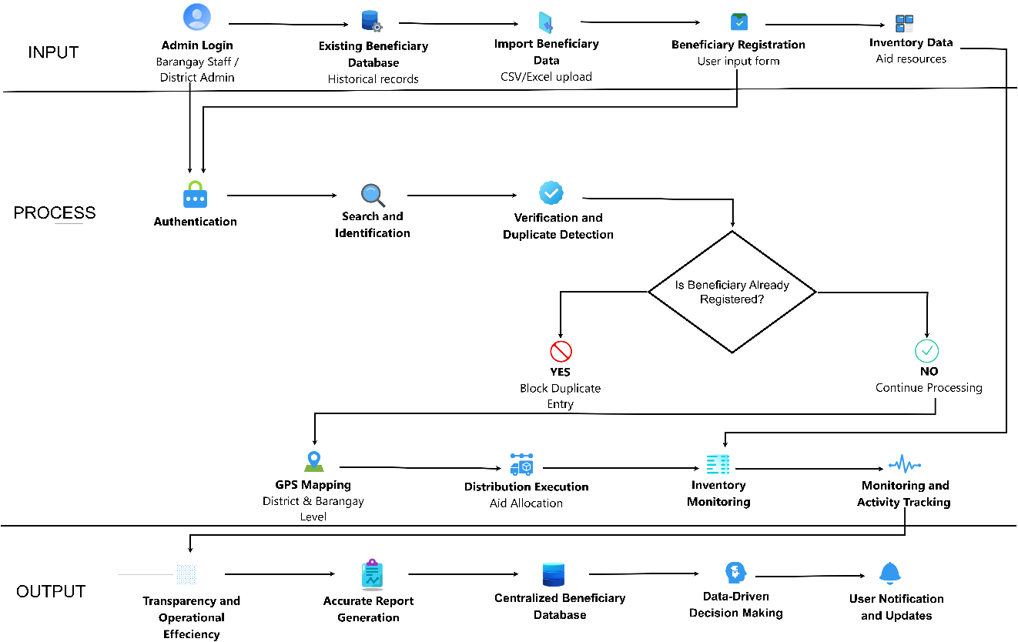
This chapter discusses the systematic and technical aspects used in this system.
Figure 4. Conceptual Framework
The conceptual framework of the Ayuda Distribution and Monitoring System follows an Input–Process–Output (IPO) model to improve aid delivery, where in the input phase authorized administrators log into the application and manage data from existing beneficiary records, imported files, registration forms, and inventory resources; in the process phase the system performs authentication, search and identification, and verification with duplicate detection to prevent multiple entries, allowing only validated records to proceed to GPS mapping, aid distribution, inventory updates, and real-time monitoring; and in the output phase the system ensures transparency, generates accurate reports, maintains a centralized beneficiary database, and supports data-driven decision-making for efficient and equitable distribution of assistance.
Software and Hardware Requirements

Software Requirements
COMPONENTS | DESCRIPTION
JAVASCRIPT  (ES6+) | JavaScript is a client-side scripting language that adds interactivity, enabling instant updates of distribution status, validating admin inputs, displaying confirmation messages, and enhancing the responsiveness of the monitoring dashboard.
PHP  (v8.x) | PHP is a server-side scripting language used to handle the system’s core logic, including managing beneficiary data, updating Ayuda distribution status, and generating monitoring reports for administrators.
HTML  (v5) | HTML is a markup language used to structure web pages. It is used to structure the admin monitoring dashboard, beneficiary tracking tables, status indicators, and report pages used only by administrators.
CSS  (v3) | CSS styles the web interface, ensuring the admin panel and reports are clear and easy to read.
MySQL  (v8.x) | MySQL is a relational database system that stores beneficiary records, Ayuda distribution status, and monitoring logs for tracking and reporting.
XAMPP  (v8.x) | XAMPP is a local server used to develop and test the admin monitoring system before deployment.
VISUAL STUDIO  CODE | Visual Studio Code is a source-code editor for  software development used by developers to write, edit, debug, and maintain the system code.
GOOGLE CHROME  (latest) | Google Chrome is a web browser used by  administrators to access the system and monitor Ayuda distribution and beneficiary status.

Hardware Requirements
COMPONENTS | DESCRIPTION
DESKTOP or  LAPTOP | Desktop or Laptop is a computing device used by administrators to encode beneficiary data, update ayuda distribution status, monitor completion, and generate tracking reports.
PRINTER | Printer is a device used to print monitoring reports, beneficiary tracking lists, and distribution summaries for documentation and auditing purposes.
INTERNET CONNECTION | Internet connection is a network service that enables online access. It allows administrators to access the system in real time and ensures synchronized data monitoring.

Prototype Description
This section describes the initial prototype of the ayuda dstribution and monitoring app. It shows how the system helps barangay staff or district admin monitor, track, and manage the distribution of ayuda in an organized and efficient way.
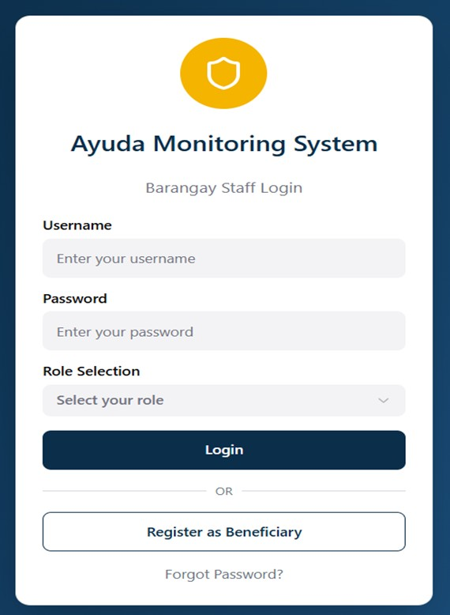

Figure 5. Login and Registration Page
The login and registration page serves as the main entrance for the aid monitoring app. Barangay workers and bosses use this screen to type in their names and passwords while picking their job role to use the management tools. For residents, a large button lets them sign up as a new member right from the same page. Also, a "Forgot Password?" link is there to help people get back into their accounts if they have trouble logging in. This two-in-one design makes sure that both workers and the community can use the system from one safe place. This setup helps everyone get started quickly and easily.

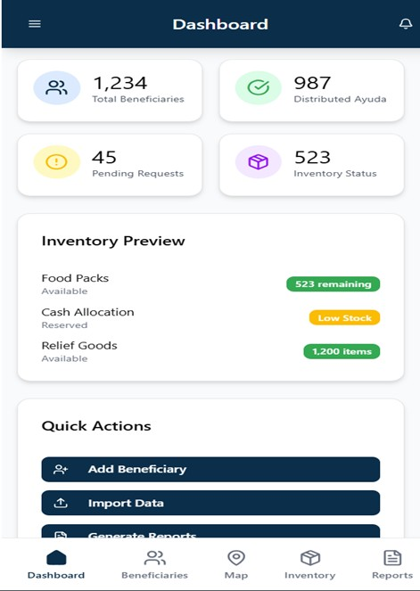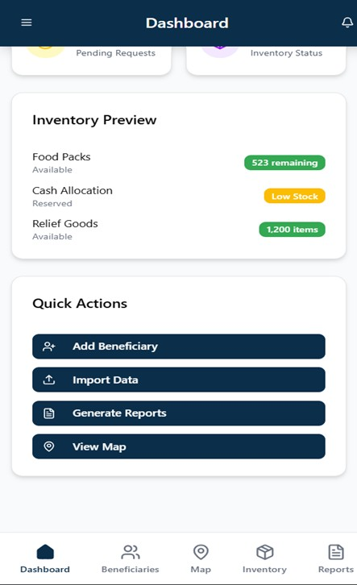

Figure 6. Staff/Admin Dashboard
Once logged in, staff are presented with a comprehensive dashboard that displays real-time statistics regarding aid distribution. The interface features highlevel summaries, such as the total number of beneficiaries (1,234) and the amount of distributed ayuda (987). An inventory preview section provides a quick glance at available food packs and cash allocations, specifically highlighting items with a "Low Stock" status. Users can also utilize "Quick Actions" to add beneficiaries, import data, or generate reports with a single click. This centralized view allows administrators to monitor pending requests and inventory levels simultaneously to ensure no resident is overlooked. By providing an immediate visual breakdown of current operations, the dashboard helps staff make data-driven decisions during high-pressure distribution periods.

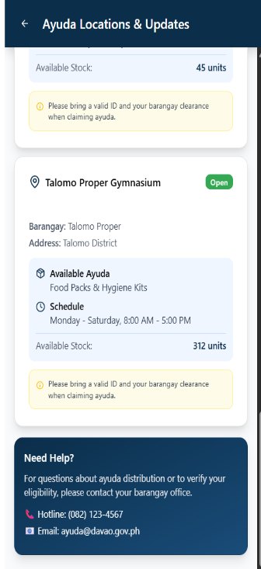
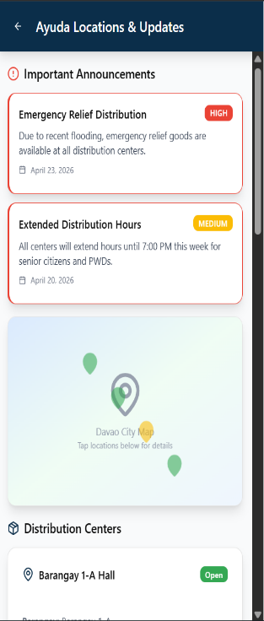
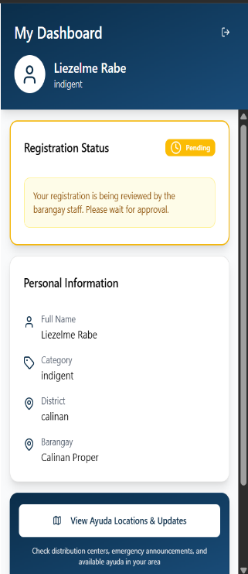
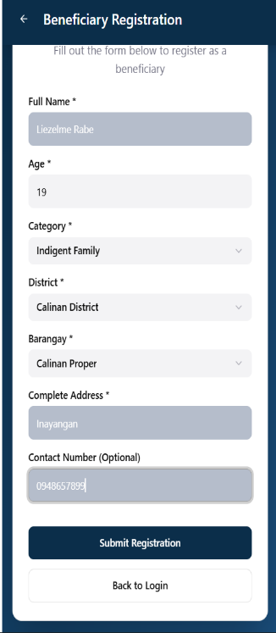
Figure 7. Beneficiary Registration and Updates
This figure illustrates the resident-facing side of the application, beginning with a registration form for personal details like name, age, and category. After submission, users can monitor their "Registration Status" to see if their application is currently being reviewed by barangay staff. The interface also provides an "Ayuda Locations & Updates" section where beneficiaries can view important announcements, such as emergency relief due to flooding. Specific distribution details, place (e.g. Talomo Proper Gymnasium), outline available stocks, and the necessary identification required to claim items. To further assist residents, the page includes direct contact information and hotlines for local barangay offices should any questions arise. This transparency ensures that beneficiaries are wellinformed about where to go and what to bring before they leave their homes. By centralizing schedules and requirements, the system minimizes confusion and reduces long wait times at distribution centers. Ultimately, this user-centric design empowers citizens by providing them with real-time access to essential government support services.
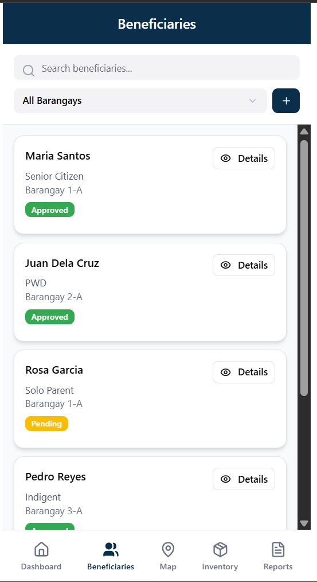

Figure 8. Beneficiary Management List
The beneficiary management screen allows staff to view and filter a complete list of registered residents within their jurisdiction. Each entry displays the individual's name, their specific category—such as Senior Citizen, PWD, or Solo Parent—and their home barangay. Status badges clearly indicate whether an application has been "Approved" or is still "Pending," helping staff prioritize their workload. A search bar and a barangay-specific dropdown menu at the top of the screen facilitate the rapid location of specific records. By clicking on the details button, staff can access the complete profile and history of each resident for a more thorough evaluation. This streamlined organizational structure ensures that no applicant is lost in a large database of names. With these tools, the barangay can maintain an accurate, up-to-date registry that is essential for fair resource allocation.
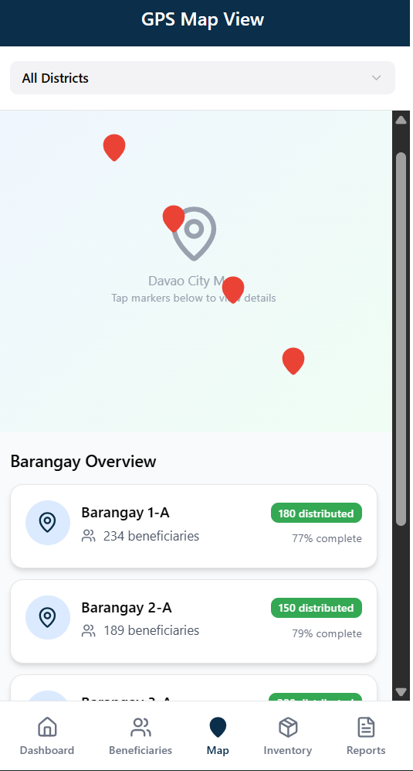

Figure 9. GPS Map View
The GPS Map View provides a geographical visualization of distribution points across Davao City. Staff can use the interactive map to tap on markers and view specific location details or filter results by district. Below the map, a "Barangay Overview" provides a list showing the number of beneficiaries and items distributed in areas like Barangay 1-A and Barangay 2-A. Progress bars accompanying these entries show the percentage of completion for each area, such as a 79% completion rate for Barangay 2-A. This spatial data helps administrators identify underserved neighborhoods that may require additional logistics or personnel support. By integrating real-time mapping, the system ensures that the distribution of resources is balanced and responsive to the needs of different locations.

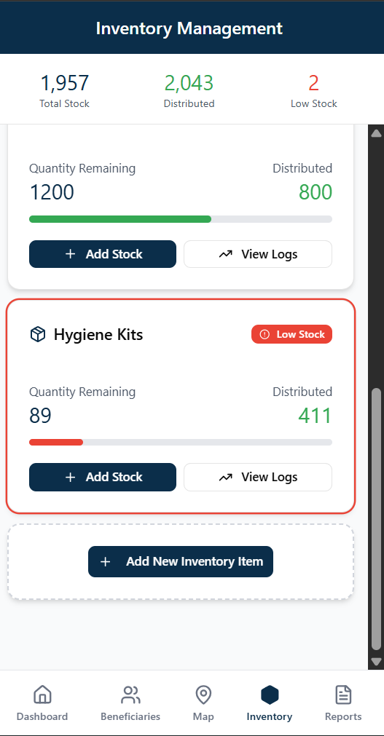
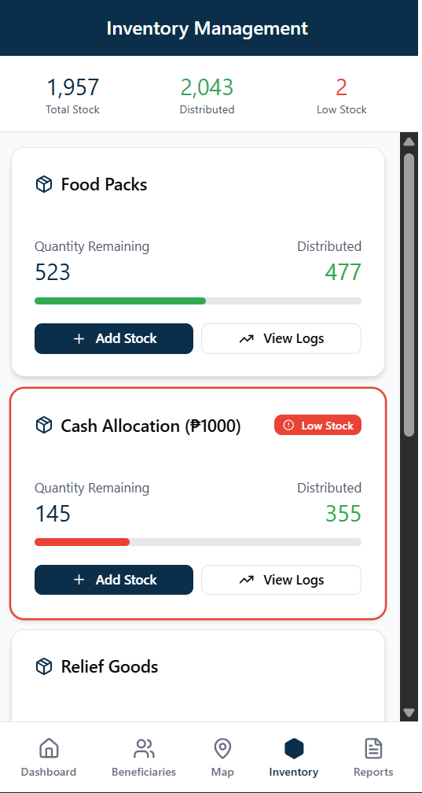

Figure 10. Inventory Management
The Inventory Management interface tracks the city's total stock and distribution levels for various relief items. Detailed cards for items like Food Packs, Hygiene Kits, and Cash Allocations show the quantity remaining versus the amount already distributed. To ensure continuous supply, the system uses red progress bars and "Low Stock" labels to warn staff when items, such as the 89 remaining hygiene kits, need replenishment. Staff can interact with these cards to add new stock, view transaction logs, or register entirely new inventory items. This organized tracking system prevents the mishandling of resources and ensures that every item is accounted for from arrival to distribution. By providing clear visual alerts, the system helps administrators coordinate with suppliers in advance to avoid any disruption in service. Ultimately, this module ensures that the right amount of aid is always available to meet the immediate needs of the community.

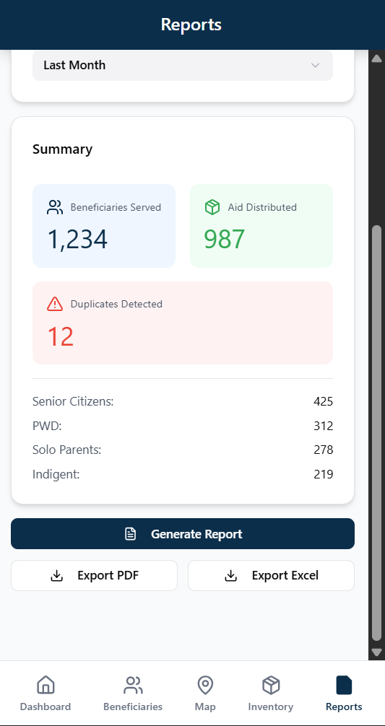
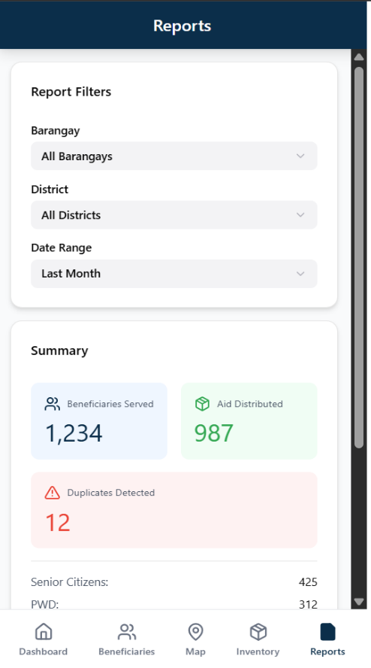

Figure 11. Reports and Analytics
The Reports screen allows administrators to generate detailed data summaries by filtering for specific barangays, districts, and date ranges. The summary section provides a numeric breakdown of beneficiaries served by type, including counts for Senior Citizens, PWDs, Solo Parents, and Indigents. It also includes a critical "Duplicates Detected" metric to help maintain the accuracy and integrity of the distribution records. Once the data is reviewed, users can generate the report and export it as a PDF or Excel file for official use. This automated reporting feature replaces manual paperwork, allowing for a more transparent and audit-ready tracking system. By providing a clear bird's-eye view of community impact, the system helps local government units justify resource requests and plan for future programs.
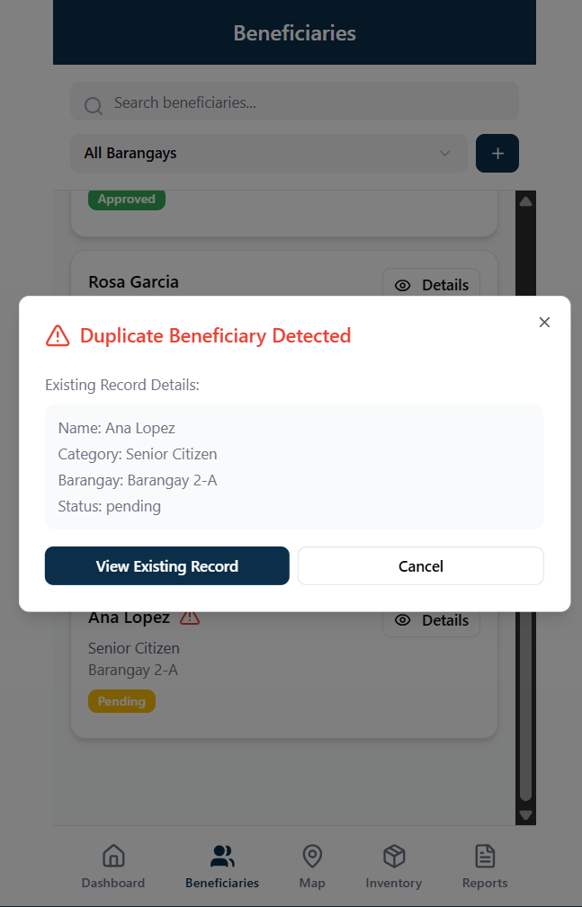

Figure 12. Duplicate Detection Alert
This figure shows the system's automated security feature designed to prevent double claiming of aid. When a staff member attempts to process a beneficiary who is already in the database, a "Duplicate Beneficiary Detected" popup warning appears. This alert provides the details of the existing record, such as the name Ana Lopez and her current pending status in Barangay 2-A. Staff are given the option to either view the existing record for verification or cancel the current registration attempt. This safeguard is essential for maintaining a fair and honest distribution process across all districts. It helps eliminate human errors and intentional fraud by cross-referencing information in real time. Ultimately, this feature protects the system's integrity and ensures that resources are shared equitably among all families.
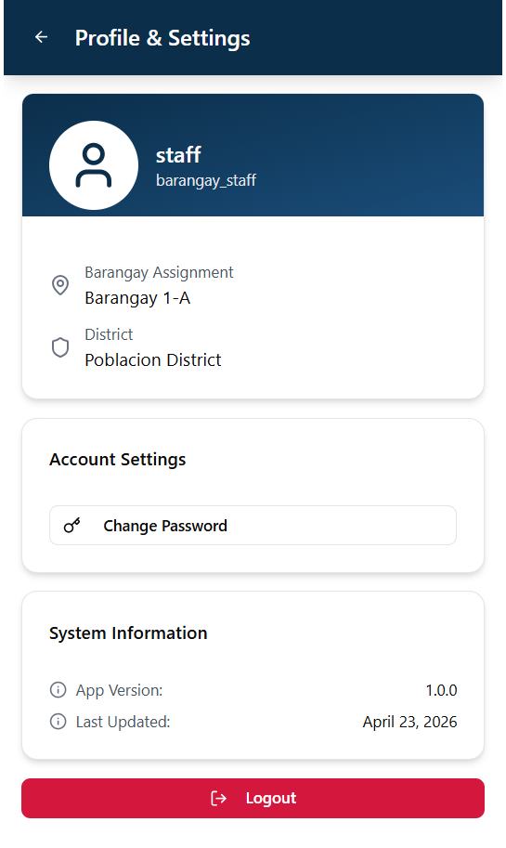

Figure 13. Profile and Settings
The Profile and Settings page provide account-specific details for the logged-in barangay staff member. It displays their name, role, and specific assignment, such as being stationed in the Poblacion District for Barangay 1-A. The page also contains "System Information," noting that the application is version 1.0.0 and was last updated on April 23, 2026. A clear red "Logout" button at the bottom ensures that users can securely end their sessions. In the account settings section, staff members have the option to change their passwords to maintain high security standards. This centralized hub helps users confirm they are operating under the correct jurisdiction before starting their tasks. By keeping technical details visible, the app ensures that all staff are using the most current and supported version of the software.
REFERENCES
Albert, J. R. G., Dumagan, J. C., & Martinez, A. (2020). Social protection in the Philippines: Programs, challenges, and reforms. Philippine Institute for
Development Studies.
https://pidswebs.pids.gov.ph/CDN/PUBLICATIONS/pidsdps2020.pdf
Alsharo, M., Gregg, D., & Ramirez, R. (2021). Virtual team effectiveness: The role of knowledge sharing and trust. Journal of Knowledge Management, 25(2),
230–250. https://doi.org/10.1108/JKM-10-2019-0563
Calder, A., & Watkins, S. (2021). IT governance: An international guide to data security and ISO27001/ISO27002. Kogan Page.
Chen, J., Zhang, Y., & Wilson, C. (2022). Cloud-based platforms for disaster response and public service efficiency. International Journal of Disaster Risk Reduction, 70, 102784. https://doi.org/10.1016/j.ijdrr.2022.102784
Davenport, T. H., & Ronanki, R. (2018). Artificial intelligence for the real world. Harvard Business Review, 96(1), 108–116.
Dwivedi, Y. K., Hughes, D. L., Ismagilova, E., et al. (2021). Setting the future of digital and social media marketing research. International Journal of
Information Management, 59, 102168.
https://doi.org/10.1016/j.ijinfomgt.2020.102168
Gentilini, U., Almenfi, M., & Dale, P. (2021). Social protection and jobs responses to COVID-19: A real-time review of country measures. World Bank. https://doi.org/10.1596/33635
Gupta, S., & Verma, R. (2021). Data matching techniques for large-scale social databases. Journal of Data and Information Quality, 13(2), 1–20. https://doi.org/10.1145/3442376
Hanna, R., & Olken, B. A. (2020). Universal basic income vs targeted transfers:
Evidence from developing countries (Working Paper No. 26639). National Bureau of Economic Research. https://doi.org/10.3386/w26639
Janssen, M., van der Voort, H., & Wahyudi, A. (2021). Data-driven government:
Challenges and opportunities. Government Information Quarterly, 38(4), 101633. https://doi.org/10.1016/j.giq.2021.101633
Khan, S., Khan, A., & Khan, M. (2022). Multi-factor authentication in cloud computing: A systematic review. Journal of Cybersecurity and Privacy, 2(1),
1–18. https://doi.org/10.3390/jcp2010001
Kumar, A., Singh, R., & Dwivedi, Y. K. (2022). Real-time analytics in public sector decision-making: A systematic review. Public Administration Review, 82(4), 710–723. https://doi.org/10.1111/puar.13463
Laudon, K. C., & Laudon, J. P. (2022). Management information systems: Managing the digital firm. Pearson.
Luna, E., Reyes, M., & Santos, J. (2021). Digital tools and disaster response efficiency in local governments. Disaster Prevention and Management, 30(3), 345–358. https://doi.org/10.1108/DPM-08-2020-0265
Martin, E., Nolte, I., & Vitolo, E. (2016). The four Cs of disaster partnering:
Communication, cooperation, coordination and collaboration. Journal of Humanitarian Logistics and Supply Chain Management, 6(1), 22–42.
https://doi.org/10.1108/JHLSCM-07-2015-0030
Mertens, D. M. (2021). Research and evaluation in education and psychology. SAGE Publications.
Organisation for Economic Co-operation and Development. (2021). Digital government strategies for transforming public services. OECD Publishing. https://doi.org/10.1787/4de9f5bb-en
O’Leary, D. E. (2021). Evolving information systems and cloud computing in government. Intelligent Systems in Accounting, Finance and Management, 28(2), 90–99. https://doi.org/10.1002/isaf.1480
Park, Y., Kim, J., & Lee, H. (2023). Automated detection of duplicate records using machine learning. Computers in Human Behavior, 140, 107566. https://doi.org/10.1016/j.chb.2022.107566
Patton, M. Q. (2020). Utilization-focused evaluation. SAGE Publications.
Sharma, R., Gupta, A., & Singh, P. (2023). Multi-layer security frameworks for government information systems. IEEE Access, 11, 45000–45015.
https://doi.org/10.1109/ACCESS.2023.3245120
Stallings, W. (2022). Cryptography and network security: Principles and Practice. Pearson.
United Nations Development Programme. (2022). Digital government and public service delivery. https://www.undp.org/publications/digital-governmentpublic-service-delivery
Wailissa, S., & Muharromah, S. (2023). Inclusion and exclusion errors in social assistance programs. Journal of Social Policy, 52(3), 589–607.
https://doi.org/10.1017/S0047279422000456
Whitman, M. E., & Mattord, H. J. (2021). Principles of information security.
Cengage Learning.
World Bank. (2021). Social protection and digital infrastructure. World Bank.
https://doi.org/10.1596/978-1-4648-1760-7

